Artificial Intelligence sample questions Unit-3 to Unit-5
- Discuss Min-Max algorithm
- Apply alpha beta pruning on following example considering first node as MAX.
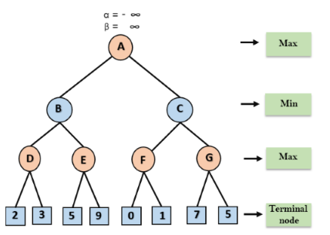
- Explain with an example the use of unification algorithm.
- What is Knowledge Representation?
- How can computer acquire knowledge? What is its role in problem solving?
- Explain briefly the difference between procedural and declaration knowledge.
- Discuss various approaches and issues in knowledge representation. Also discuss various Problems in representing knowledge
- Discuss forward chaining and backward chaining.
- Explain the resolution procedure in detail.
- Represent the following statements in predicate logic:
i) Marcus tried to assassinate Caesar.
ii) All Pompeian’s were Roman.
iii) All Romans were either loyal to Caesar or hated him.
iv) Everyone is loyal to someone.
v) People only try to assassinate rulers they are not loyal to.

- Give the steps involved in converting predicates into clause form. Give an example in each step.
- Consider the following problem.
• John likes all kinds of food.
• Apples are food.
• Chicken is food.
• Anything any one eats and isn’t killed by is food.
• Bill ate peanuts and still alive.
• Sue eats everything Bill eats.
Convert the formulas into clause form. ii) Prove that “John likes peanuts” using resolution
- Explain the phases in building expert system.
- Briefly explain the architecture of expert systems.

- Explain the Applications of the Expert systems.
- What is probabilistic reasoning, and why is it essential in AI?
- Explain about knowledge acquisition.
- Write characteristic features of Expert system
- Discuss basic components of Expert systems.
- Discuss applications of expert system.
- What is a Bayesian network, and how is it used in AI?
- What is Dempster-Shafer theory, and how does it differ from Bayesian probability?
- What is planning in AI, and why is it important?
- What are the key components of a planning system?
- What is goal stack planning, and how does it work?
- What is hierarchical task network (HTN) planning?
- List few examples of expert systems.
30. What is knowledge representation?Represent the following statements in predicate logic:
i) Marcus tried to assassinate Caesar.
ii) All Pompeian’s were Roman.
iii) All Romans were either loyal to Caesar or hated him.
iv) Everyone is loyal to someone.
v) People only try to assassinate rulers they are not loyal to
31. Write a short note on i) Expert systems ii) Knowledge Acquisition.

